Vol. xx, No. yy, month year, page. ab-cd

ISSN 2598-3245 (Print), ISSN 2598-3288 (Online)

DOI

Available online at http://eltikom.poliban.ac.id

**RASANUSA: ENHANCING AUTHENTIC TRAVEL THROUGH LOCAL COMMUNITY-DRIVEN DIGITAL INNOVATION**

**Adnin Atmadewati Ashrini 1*, Daniel Nadeak 2, Arief Rachman Wicaksana 3, Indra Aulia 4**

1,2,3,4 Teknologi Informasi, Universitas Telkom, Indonesia

Email: atninin@gmail.com1, daniellnadeakk@gmail.com2, ariefrw2005@gmail.com3, indraaul@telkomuniversity.ac.id4

Received: xx month year – Revised: xx month year – Accepted: xx month year

***ABSTRACT***

*This study aims to design and evaluate RasaNusa, a digital platform connecting travelers with local businesses to support sustainable tourism. The approach used is User-Centered Design (UCD) combined with Development Research methodology, involving users in every stage of the development process. Data collection techniques included observation, in-depth interviews, and questionnaires directed at travelers and local service providers. The user needs analysis resulted in both functional and non-functional requirements, which formed the foundation for prototype development. Evaluation was carried out using heuristic methods and usability testing involving over 30 respondents. The evaluation results show that the RasaNusa prototype is generally good in terms of navigation, design, and visual consistency. However, several areas need improvement, including system feedback, error messages, and accessibility of key features. The study concludes that the UCD approach is effective in developing an application aligned with user needs while promoting local business empowerment. Further development is recommended to refine features and enhance the overall user experience.*

***Keywords****: User-Centered Design, travel application, usability, local MSMEs, sustainable tourism*

# Introduction

The Indonesian government set a target of 20 million international tourist arrivals in 2019. To achieve this target, the Ministry of Tourism developed a strategy based on Information and Communication Technology, including the Competitive Destination Model. This model is highly important, as most people today, including local tourists, search for information and share experiences through technology. In this context, the development of the Travel 2.0 concept has had a major impact on the tourism sector, which now places greater emphasis on the needs of local tourists. Technology allows local tourists to be more involved in the process of searching and booking tourism services and provides them with direct access to reviews and experiences from other travelers. This phenomenon encourages a shift from conventional business models to peer-to-peer models, which strengthen direct interaction between local tourists and local service providers.

The increase in local tourist engagement is also driven by the use of technology that makes it easier to access information about destinations and local services. Digital platforms allow local tourists to access a variety of offerings from local service providers that were previously difficult to reach. With this technology, local tourists can share their experiences directly, provide reviews, and recommend services they enjoy. This contributes to the empowerment of local businesses, where local service owners can promote their products and services to a wider market. However, challenges still exist, such as dependence on third parties and increasing competition, which often require local service providers to pay commissions to the platforms that connect them with tourists[1].

Although major progress has been made through digital platforms, there remains a gap in understanding their role in promoting sustainable tourism. Sustainable tourism, as defined by the World Tourism Organization, is tourism that considers current and future economic, social, and environmental impacts, and meets the needs of visitors, the industry, the environment, and host communities. One of the main challenges is how digital platforms can integrate these sustainability principles, particularly about sustainable resource management, equal economic participation, and responsible tourism governance. While digital platforms have shown potential in optimizing pricing strategies and facilitating more personalized experiences, they also raise concerns regarding market concentration, data privacy, and the digital divide among local tourism operators.

This study aims to address the existing challenges by analyzing the dual role of digital platforms in supporting sustainable tourism. It examines how digital platforms can facilitate the promotion of environmentally friendly tourism and support the empowerment of local businesses, while also identifying issues related to digital dependence, economic concentration, and inadequate regulatory oversight. The main focus of this research is to explore how digital platforms influence market structure[2].

# Literature Review

In digital application development, the resulting design must not only be innovative but also aligned with user needs. This literature review discusses three main concepts that form the foundation of the research, namely the User-Centered Design (UCD) approach as a design method, UI/UX principles as the basis for user interface and experience, and system usability as a benchmark for the application's quality and user comfort during use.

## User-Centered Design

User-Centered Design (UCD) is an approach in the digital product development process that places users at the core of attention. The goal of UCD is to create solutions that align with users’ needs, goals, and limitations by actively involving them throughout all stages of the design process. By prioritizing the user’s perspective from the outset, developers can design interfaces and system functionalities that are genuinely relevant to real-world conditions.

The UCD approach is highly effective in designing web and mobile-based travel applications, as users are involved in need identification, design testing, and interface refinement. This user involvement ensures that features and interaction flows align with their expectations in real usage contexts, including both travelers and local service providers [3].

In the context of developing a tourism marketplace application, the implementation of UCD becomes even more crucial, as the application serves two distinct user groups with different needs—tourists and local MSME actors. By applying UCD, the RasaNusa application is designed not only to be functional but also to ensure interaction comfort, information clarity, and usage efficiency, all based on direct user experience.

## Development Research

Development Research is a research approach used to develop and evaluate new products or processes across various fields, including education and psychology. This method focuses on an iterative cycle of development, evaluation, and continuous improvement, allowing research outcomes to be more applicable and relevant to practical needs. Development research is often employed to create new theories, enhance understanding of specific phenomena, or produce evidence-based solutions that can be applied in real-world contexts.

In practice, this method involves several key stages, including needs analysis, initial concept development, implementation, and repeated evaluation. Researchers typically begin by identifying a problem or challenge within a particular field, then develop solutions that can be tested and refined based on empirical data. This process enables more systematic and evidence-based development, ensuring that the final outcomes have a significant impact on the field under study. With its flexible and evaluation-driven approach, development research can generate innovations that evolve in response to emerging needs and changing environments.

## Design UI/UX

User Interface (UI) design and User Experience (UX) are critical aspects in the development of digital applications, not only in terms of functionality but also in ensuring comfort and ease of use. UI encompasses visual elements such as buttons and layout, while UX focuses on interaction flow and user satisfaction.

Studies on UI/UX prototype development based on the User-Centered Design approach show that direct user involvement from the early stages, ranging from needs identification to prototype evaluation, significantly enhances navigation efficiency and overall user experience [4].

In the context of the RasaNusa application, this approach is essential to address the needs of both tourists and local MSME actors in a balanced manner, aiming to increase user adoption and loyalty.

## System Usability

System usability refers to the ability of a system to be used effectively, efficiently, and to provide satisfaction to users. This aspect includes learnability, speed, memorability, minimal errors, and user satisfaction.

An evaluation of the usability of the Maxim application (a local online transportation service) using the User-Centered Design approach through two iterative phases resulted in significant improvements in task completion speed and a reduction in user errors. Direct testing showed that the redesign based on user feedback improved functionality and the interface layout, making it more responsive and intuitive [5].

In the RasaNusa study, usability evaluation was also conducted at the prototype stage through direct user testing. The primary focus of the testing includes navigation, clarity of information, consistency across pages, and visual-functional satisfaction. The results of this evaluation are crucial to verify how well the application meets user expectations and to strengthen the overall user experience.

# Research Method

This research uses the Development Research method and User-Centered Design (UCD) with a qualitative approach to design and develop RasaNusa, a tourism marketplace platform aimed at effectively and efficiently connecting tourists with local business actors. The Development Research method was chosen because it allows for progressive application development with continuous adjustments based on feedback from users and other stakeholders. This approach provides flexibility in creating innovative solutions that are relevant to the ever-evolving market needs.

Additionally, this research also applies the User-Centered Design (UCD) method, which focuses on the active involvement of users at every stage of the application development process. UCD ensures that the design and functionality of the RasaNusa application align with the needs and preferences of users, thus enhancing the overall user experience. The process involves user needs analysis, prototype creation, usability testing, and iterations based on feedback received. By combining the Development Research method and UCD, this study is not only focused on technology development but also ensures that the resulting application truly meets the expectations and needs of both tourists and local business actors.

This approach supports the empowerment of local businesses, where the RasaNusa application functions not only as a connecting platform but also as a tool to enhance the visibility and competitiveness of local businesses in the global market. A qualitative method is used to gain deeper insights into the challenges faced by business actors and tourists, while a quantitative method is applied to obtain more objective and representative data on user preferences. Thus, the combination of Development Research and UCD in this study provides a strong foundation for developing an innovative application that is user-centered and able to adapt to market changes.

## Data Collection Techniques

The researcher used several different data collection techniques to obtain comprehensive and representative information regarding the users and market of the RasaNusa application. These data collection techniques include:

### Direct Observation: was conducted at local business locations to understand operations, interactions with tourists, and challenges in promotion and technology use. This method allows the researcher to gain in-depth insights into the social context and behavior in a natural setting [6].

### In-Depth Interviews: were conducted with tourists and local business actors to explore their views, experiences, and expectations regarding the application being developed. This method enables the researcher to understand user needs more holistically, especially for information that cannot be obtained through observation or questionnaires [6].

### Questionnaires: were used to collect quantitative data on user preferences, needs, and satisfaction with the tourism marketplace application. This method is effective in uncovering information about usage patterns, key features, and user expectations, helping the researcher identify aspects that need improvement in the application development process [6].

## Design Tools

Several design tools were used to support the design process of the RasaNusa application. These tools assisted the researcher in designing and testing an effective prototype that aligns with user needs. The design tools used include:

1. *Figma* was used to design the RasaNusa application prototype with detailed and interactive UI designs. This tool helps in structuring user flows and interactions between application elements to enhance the user experience. Additionally, Figma supports real-time team collaboration, allowing design improvements based on user feedback.
2. *Canva* was used to create additional visual elements such as personas, empathy maps, and user journeys needed to support the RasaNusa application. With Canva, the researcher was able to design other materials necessary for the application. Canva provides various templates and design tools that facilitate the creation of professional-looking visual materials without requiring advanced graphic design skills.
3. *Spreadsheets* such as Microsoft Excel or Google Sheets, were used to systematically and efficiently analyze interview, observation, and questionnaire data. These tools allow simple statistical analysis, such as calculating frequencies, creating graphs, and identifying trends, thus helping evaluate user preferences and satisfaction for further application development.
   1. *UCD Stages*

The design process of the RasaNusa application follows the User-Centered Design (UCD) approach, which emphasizes user involvement at every stage of development. The stages carried out include:

1. Conducting direct observations and in-depth interviews with tourists and local business actors to understand their needs and expectations for the application. This process allows the researcher to gain deeper insights into the context of application usage in daily life, which is crucial for effective design that aligns with user needs [6].
2. Analyzing data from interviews and observations to identify user needs, such as ease of information search, rating systems, and interaction between tourists and business actors. Identifying these needs is essential to ensure that the developed features meet user expectations and support smoother interactions between users and service providers [6].
3. Creating an initial prototype of the application that includes visual design and user flows, then testing the prototype with users to gather feedback. This testing is critical to determine whether the prototype reflects user needs and expectations and to evaluate whether the application's usage flow is intuitive [5].
4. Collecting user feedback, evaluating the prototype, and making design improvements to better align the application with user needs. Evaluation and design refinement are iterative stages in UCD that are vital to ensure the application continues to evolve and adapt to changing user needs [7].
   1. *Heuristic Evaluation*

Heuristic Evaluation is a method used to assess the usability of a user interface by identifying issues that may hinder the user experience. This method involves comparing the application's UI/UX against established heuristic principles such as consistency, user control, and error prevention. In this evaluation, UX experts review the application design without the need for direct user involvement, making the process more efficient in identifying shortcomings and providing improvement recommendations [8].

Table 1

Heuristic Evaluation Questionnaire

|  |  |
| --- | --- |
| Heuristic principle | QUESTIONS |
| Visibility of System Status | Does the app display clear indicators (e.g. loading spinner, “loading” text)? |
| Match Between System and Real World | Are the terms, icons, and navigation flow in the app easy for users to understand? |
| User Control and Freedom | Can you easily return to the previous screen if you accidentally select the wrong category, filter, or page? |
| Consistency and Standards | Are the button styles, text sizes, and colors across the page consistent? |
| Error Prevention | When filling out the form (register/login) do you get a warning before sending the data when an error occurs (wrong email format, password does not match)? |
| Recognition Rather than Recall | Are important information such as rating, distance, and activity category already visible directly on the destination list without having to open the details? |
| Flexibility and Efficiency of Use | Are there shortcuts (e.g. quick access to booking history or favorite destinations) that make it easier for users? |
| Aesthetic and Minimalist Design | Does the layout, color selection, and spacing between elements help you focus on the main content (photo, description, action button) without getting distracted? |
| Help Users Recognize, Diagnose and Recover from Errors | If a failure occurs (e.g. failed to upload review photo), does the error message clearly tell the cause and next steps? |
| Help and  Documentation | Is the ‘Help Center’ menu easy to find and the information in it helpful? |
|  |  |
|  |  |
|  |  |
|  |  |

# Results and Discussion

* 1. *Persona Identification*

Persona is a technique used in software development to depict user characteristics in depth, including their personality, capabilities, and behaviors towards a system. This method helps developers better understand user needs, so that the system being developed can better align with user expectations and experiences [9].

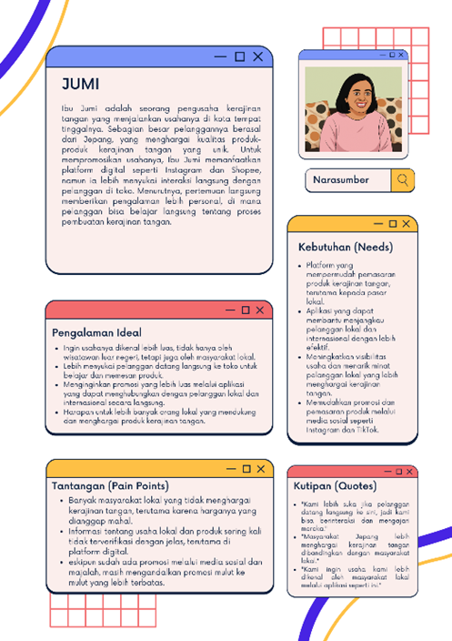

Figure 1. Persona of the Business Actor

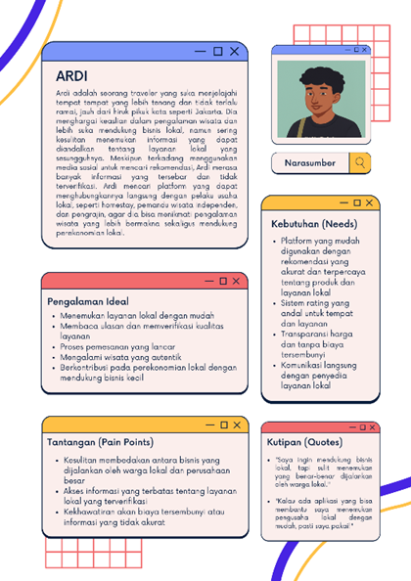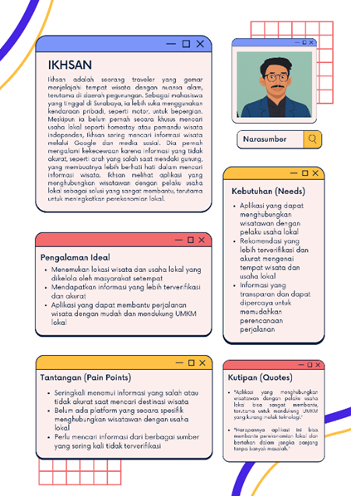

Figure 2. Persona User

* 1. *User Requirement Analysis*

User needs analysis is an important stage in the User-Centered Design (UCD) approach, as it places the user as the main focus in the design process. Data is obtained through interviews, observations, and surveys to understand user characteristics, needs, and preferences. This information is then used as the basis for developing personas, designing features, and determining appropriate interaction flows [10].

User requirements are usually categorized into functional and non-functional, both of which are important for providing an optimal experience. These needs form the basis for designing key features as well as system behavior in the RasaNusa app.

Table 2

Functional Requirement Analysis

|  |  |  |  |
| --- | --- | --- | --- |
| Code | Requirement | Description | Priority |
| F01 | The app should allow users to search for tourist destinations by category. | Users can search for tourist destinations with various categories that are easily accessible. | High |
| F02 | The app should allow booking of local services. | Users can select and order services with clear and transparent information. | High |
| F03 | The app should provide a credible and trustworthy rating and review system. | Users can view and rate or review based on their experience. | High |
| F04 | The app should provide search and filter features that allow users to search based on personal preferences. | Service prices should be clearly listed with no hidden fees, and valid information. | High |
| F05 | The app should provide search and filter features that allow users to search based on personal preferences. | Users can select and filter travel destinations based on preferences such as price, distance, and rating. | Medium |
| F06 | The app should provide automatic recommendations based on the user's location or preferences. | The app provides location and service suggestions relevant to the user's preferences. | Medium |
| F07 | The app should enable direct communication between travelers and local businesses | Users can interact directly with local businesses through chat or other features. | High |
| F08 | The app should provide an interactive map showing tourist locations and local businesses. | Users can view the location with a map that is easy to understand and integrated in the application. | High |
| F09 | The app should have secure and flexible ordering and payment features. | Users can make transactions with a wide selection of secure payment methods. | High |
|  |  |  |  |

Table 3

Non-Functional Requirement Analysis

|  |  |  |  |
| --- | --- | --- | --- |
| Code | Requirement | Description | Priority |
| NF01 | The app should have a simple and user-friendly interface design. | The app interface is easy to navigate with a responsive and intuitive display. | High |
| NF02 | The application must have a fast response time when the user opens a page or performs a search | The application response time is no more than 2 seconds to perform a search or page access. | High |
| NF03 | The application must be able to handle thousands of users simultaneously without degrading the quality. | The app can handle high loads from many active users without lag or crashes. | High |
| NF04 | The app must ensure the security of user data and transactions. | All user and transaction data must be protected with encryption and high security standards. | High |
| NF05 | The app should have a feedback and review system that can be updated continuously. | The review system can be accessed and updated in real-time by users. | Medium |
| NF06 | The app must have support for dark mode and other display modes. | Users can choose between dark mode or light mode according to their preference. | Medium |
|  |  |  |  |

* 1. *Results from Respondent Questionnaire*

Based on responses from more than 40 respondents, in general, the prototype of the RasaNusa app was rated quite well in basic aspects of user experience. Most users stated that the icons, navigation, and flow of the app are easy to understand, and the display style such as buttons and colors are consistent across different pages. However, there are a number of important aspects that still need improvement, including:

1. System indicators are not consistent: Some users reported that the loading spinner/text indicator did not appear clearly when the system was processing data.
2. Suboptimal error feedback: During the login/register process, alerts for input errors such as email or password were not always displayed, which was confusing.
3. Important information is not immediately visible: Data such as rating, distance, and activity category do not fully appear in the initial view of the destination.
4. Error messages are not informative enough: In the event of a system failure (such as failed photo upload), users do not always get an explanation of the cause and corrective steps.
5. Access to help menu & quick features is limited: Menus such as the ‘Help Center’ and shortcuts to favorite features are not easily found by most users.

In addition, some respondents provided important suggestions such as:

1. Speeding up loading time to the main page,
2. Adding filters by region,
3. Simplifying access to booking features or other destinations,
4. Improving icons and UI layout that are still too big or crowded.

To improve the quality of the RasaNusa prototype, developers are advised to:

1. Enhancing system feedback (process indicators, input validation, and error messages),
2. Optimizing the initial display to concisely present important information,
3. Adding shortcuts to favorite features and the help center,
4. Aligning visual elements such as icon size, spacing, and color to better focus on key content.
   1. *UI/UX Design*

The UI/UX design of RasaNusa application is based on the results of persona identification and user needs analysis. This design aims to create an intuitive, engaging, and effective user experience. Here is the design developed to match the previously identified user needs. For more details, here is a UI/UX design image that illustrates the interface and user experience of the RasaNusa app.

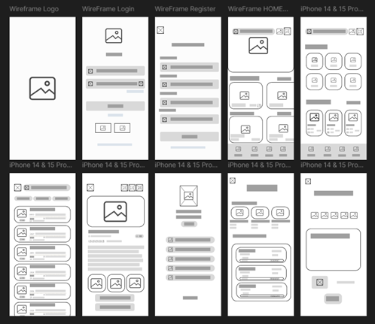

Figure 3. Wireframe

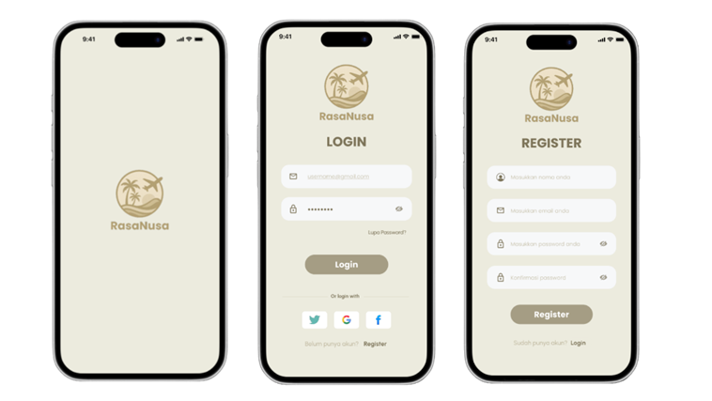

Figure 4. Login and Register Page of RasaNusa App

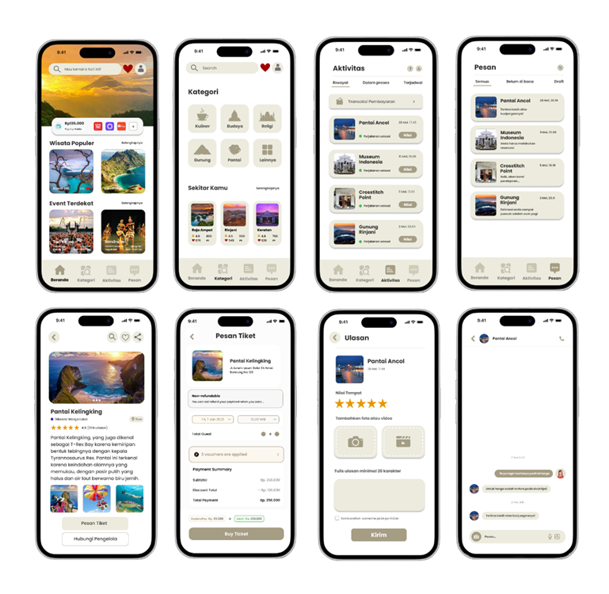

Figure 5. Prototype of RasaNusa App

* 1. *Results of Heuristic Evaluation*

The heuristic evaluation was conducted by involving 40 respondents consisting of various groups, most of whom were students with educational backgrounds in programming. Each respondent was asked to rate the interface of the RasaNusa app based on Nielsen's 10 heuristic principles. Based on the evaluation results, some of the main findings that can be concluded are as follows:

Table 4

Heuristic Evaluation

|  |  |  |  |
| --- | --- | --- | --- |
| Heuristic principle | Findings | Improvement Suggestions | Severity |
| Visibility of System Status | There is no loading spinner indicator throughout the page (e.g. when switching pages, login process). | Add a loading spinner on every page transition and add a “Login Successful” notification | 3 |
| Match Between System and Real World | Word terms and icons are generally easy to understand but improvements are needed to the “Category” icon which is considered similar to the Settings icon. | Change the “Category” icon to one that actually symbolizes the category | 2 |
| User Control and Freedom | The app should have a “Back” button on every page. | Keep the “Back” icon (←) appearing at the top left of each screen consistently. | 1 |
| Consistency and Standards | Colors, icons, and layout are consistent across pages but need improvement on the font size in “Visit History” in the Profile section is not aligned between title and content. | Apply a consistent font size e.g. for Title of all pages use 16 pt, and body text 14 pt, and subtext 12 pt. | 2 |
| Error Prevention | There is no validation pop-up or notification before submitting the form (Register/Login). | Add real-time validation e.g. If the email format is invalid (without “@” or “.com”), display the message “Invalid email format.” and add a confirmation pop-up before important transactions e.g. “Are you sure you want to book this ticket?” | 3 |
| Recognition Rather than Recall | Stating that information such as rating, distance, and category are easy to recognize but need improvement on the rating icon (star) and distance icon (map-pin) less contrast with background cream. | Increase the color contrast of the star icon (rating) and location pin (distance) | 1 |
| Flexibility and Efficiency of Use | There is a shortcut with a heart icon for quick access to favorite destinations | Keep the heart icon for shortcuts to favorite destinations | 1 |
| Aesthetic and Minimalist Design | The design is clean and minimalist, focusing on the main content (photo, description, action button) but needs improvement on the Spacing between elements (card, button, form) is too tight which seems claustrophobic. | Keep the minimalist style, but add padding/margin between cards, buttons, and form fields so that the appearance does not pile up. | 2 |
| Help Users Recognize, Diagnose and Recover from Errors | There is no pop-up or error message when a failure occurs (e.g. failed to upload review photos, timeout during booking). | Add modal error pop-ups for every failure (photo upload, connection timeout, etc.) | 3 |
| Help and  Documentation | There is already a Help Center menu on the profile page but the “?” (Help Center) icon on the Profile is not prominent enough to be noticed. | Add the “?” (Help) icon to appear in the header of several pages instead of just the Profile page, for easier access. | 2 |
|  |  |  |  |

* 1. *Results of Usability Evaluation*

In the usability goals stage, we set six key objectives to ensure that the RasaNusa app can be used effectively, efficiently, and enjoyably. The focus of this evaluation includes effectiveness, efficiency, learnability, memorability, fault tolerance, and overall user satisfaction. These objectives are set out in the following table:

Table 5

Usability Evaluation

|  |  |
| --- | --- |
| Aspects | Usability Goals |
| Effectiveness | Users can browse through the list of destinations, open details, and complete the ticket booking to final confirmation in a maximum of 5 steps. |
| Efficiency | The login → Search → Select destination → Checkout process takes less than 2 minutes, aided by the bottom navigation menu and search history feature. |
| Learnability | New users can understand the menu structure (Home, Categories, Activities, Chat) and basic icons (Favorites ❤️, Back ←, Route) without a tutorial, within ≤ 1 minute the first time. |
| Memorability | Existing users instantly recognize the main menus/icons without needing to relearn; the menu structure, favorite icons, and “Back” button are consistent across pages. |
| Error Tolerance | The form (register/login) performs real-time validation (email @.com, password at least 8 characters). In case of failure (review upload, booking timeout), a pop-up error appears with instructions to “Try Again” or “Check Connection.” |
| Satisfaction | The minimalist design with a beige color palette, contrasting icons and text, and smooth navigation is expected to enhance the feeling of satisfaction and comfort while using the app. |
|  |  |
|  |  |
|  |  |
|  |  |

# Conclusion

This research successfully achieved the objectives stated in the Introduction, namely designing and evaluating the RasaNusa application as a platform that connects tourists with local businesses. The results of the needs analysis, design with the User-Centered Design (UCD) approach, and heuristic evaluation show that the application has met user expectations in terms of navigation, appearance, and main features. Some aspects still need to be improved, such as error feedback and access to help features. In the future, this application has the potential to be further developed with the integration of recommendation systems, interface personalization, as well as expansion of the scale of implementation to support sustainable tourism more broadly.

References

1. R. Briandana, I. A. Ananda, dan M. M. Ahmad, “Pengalaman wisatawan Indonesia dalam era digitalisasi,” Bricolage: Jurnal Magister Ilmu Komunikasi, vol. 10, no. 1, hlm. 1–14, 2024. [Online]. Tersedia: <https://journal.ubm.ac.id/index.php/bricolage/article/view/4693/2851.> Diakses pada: 10 Jun. 2025.
2. Y. Liu, Y. Zhang, dan J. Li, “Peran platform pariwisata digital dalam memajukan pariwisata berkelanjutan di era Industri 4.0,” Sustainability, vol. 17, no. 8, art. 3482, 2025. [Online]. Tersedia: <https://www.mdpi.com/2071-1050/17/8/3482.> Diakses pada: 10 Jun. 2025.
3. N. A. Ismail, S. F. Nizam, S. Yuen, L. Hasan, S. E. Mohamed, W. Y. Leng, dan K. K. Allah, “User-centred design and evaluation of web and mobile based travelling applications,” International Journal of Advanced Computer Science and Applications, vol. 12, no. 8, hlm. 456–462, 2021. [Online]. Tersedia: <https://www.thesai.org/Downloads/Volume12No8/Paper_54-User_centred_Design_and_Evaluation.pdf.> Diakses pada: 10 Jun. 2025.
4. A. Subiyakto dan E. Nurmiati, “UI/UX Design Prototype for Enhancing User Experience using User-Centered Method,” Semarang Journal of Informatics (SJI), vol. 8, no. 2, hlm. 45–60, 2023. [Online]. Tersedia: https://journal.unnes.ac.id/nju/index.php/sji/article/view/47528. Diakses pada: 10 Jun. 2025.
5. R. D. Saksono, D. Sulistyorini, S. R. Sagita, K. Kasiyah, dan L. Sadita, “Usability Evaluation and Interface Design Improvement for the Maxim Application with User‑Centered Design Approach,” Jurnal Sistem Informasi (Journal of Information System), vol. 20, no. 1, Apr. 2024. [Online]. Tersedia: <https://www.researchgate.net/publication/379580911_Usability_Evaluation_and_Interface_Design_Improvement_for_the_Maxim_Application_with_User-Centered_Design_Approach.> Diakses pada: 10 Jun. 2025.
6. Wani, A. S., & Dutta, R. (2024). "Observational Techniques in Qualitative Research: Application in Service-Based Platforms," Journal of Information Science and Social Engineering, vol. 12, no. 1, pp. 115–125. [Online]. Tersedia: <https://samudrapublisher.com/index.php/JISOSEPOL/article/view/238/186.> Diakses pada: 10 Jun. 2025.
7. Suryanto & Prabowo. (2022). "Evaluasi Penggunaan Metode User-Centered Design dalam Aplikasi Pariwisata," Jurnal Teknologi Pariwisata, vol. 7, no. 1, 2022. [Online]. Tersedia: <https://journal.ubm.ac.id/index.php/bricolage/article/view/4693/2851.> .Diakses pada: 10 Jun. 2025.
8. M. R. Silalahi, L. M. Michelli, H. Umayasyah, D. A. Mu'adin, dan B. P. Zen, “Evaluasi Heuristik dan System Usability Scale UI/UX pada Aplikasi ‘Makan Kuy’,” Jurnal Ilmiah Media Sisfo, vol. 18, no. 1, hlm. 57–67, 2024. [Online]. Tersedia: <https://ejournal.unama.ac.id/index.php/mediasisfo/article/view/1475/1315.> Diakses pada: 10 Jun. 2025.
9. [1]. W. Andhika, M. Iqbal, M. Nur, dan R. D. Nugroho, “Teknik Representasi Kebutuhan Pengguna Menggunakan User Persona (Studi Kasus: Relasi Antara Presensi dengan Kemampuan Kompetensi),” Jurnal Teknologi Informasi dan Ilmu Komputer (JTIIK), vol. 8, no. 2, hlm. 245–252, Apr. 2021. [Online]. Tersedia: <https://ejournal.unama.ac.id/index.php/mediasisfo/article/view/1475/1315.> Diakses pada: 10 Jun. 2025.
10. Y. S. Purbo, F. S. Utomo, dan Y. Purwati, “Analisis dan perancangan antarmuka aplikasi wisata menggunakan metode User-Centered Design (UCD),” Jurnal Teknologi Terpadu, vol. 9, no. 2, hlm. 123–132, 2023. [Online]. Tersedia: <https://www.researchgate.net/publication/376456514_ANALISIS_DAN_PERANCANGAN_ANTARMUKA_APLIKASI_WISATA_MENGGUNAKAN_METODE_USER-CENTERED_DESIGN_UCD.> Diakses pada: 10 Jun. 2025.